
AIX Power Virtual Server Protection on IBM Cloud Using Agent based RBR
Version 8.2.6

DISCLAIMER
IBM believes that the information in this publication is accurate as of its publication date. The information is subject to change without notice.
COPYRIGHT
©IBM Corporation 2003, 2021. All Rights Reserved.
Printed December 2021.
Use, copy, and distribution of any IBM software described in this publication needs an applicable software license.
No part of this product or document may be reproduced, stored in a retrieval system, or transmitted, in any form by any means, electronic, mechanical, photocopy, recording, or otherwise, without the prior written authorization of IBM Corporation and its licensors, if any.
Revision History
Document Version | Revision Date | Sections Updated | Pages Updated | Supported Product Version
8.1  8.2.0  8.2.6 | June 2020 | Created | NA | 8.1.x
8.1  8.2.0  8.2.6 | June 2021 |  |  | 8.2.x
8.1  8.2.0  8.2.6 | December 2021 | FOTE Workflow on-prem to cloud: |  | 8.2.x
8.1  8.2.0  8.2.6 |  | Adding AIX management Service
8.1  8.2.0  8.2.6 |  | Group creation section
8.1  8.2.0  8.2.6 |  | JSON upload section
8.1  8.2.0  8.2.6 |  | FOTE Workflow Cluster OnPrem to Cloud:

Contents
Introduction 5
Technology Overview 5
IBM Power Systems Virtual Servers: 5
IBM CloudNative Resiliency Block Replicator (RBR) 7
Pstore 7
Mobility Groups 7
Architecture Overview 8
Prerequisites 9
Supported Platforms and Versions 13
Known Limitations 13
Configuration 13
Sites 13
Discovery 13
Management service 13
Adding AIX management Service 14
Viewing AIX Credentials 16
Editing AIX Credentials 17
Adding BlockReplicator-V2 management service 17
Creating Recovery Group 18
Subsystem Discovery 22
Component 22
Dataset 22
Protection Schema 23
Group Monitoring 23
RPO/RTO Monitoring 23
Replication Monitoring 23
Datalag 24
Drills 24
Failover Test Exercise 24
FOTE Workflow on-prem to the cloud: 24
Reports 29

Introduction
This document describes the AIX application recovery solution using a built-in and well-integrated guest OS-based continuous replication capability of IBM Resiliency Block Replicator. It covers Replication monitoring and DR Drills (Failover test exercise) using IBM CloudNative AGENT BASED RBR replicator for AIX power VS workloads.

Technology Overview
This solution is based on LPAR protection on IBM Power system virtual servers in IBM Cloud and recovery on other IBM Power system virtual servers’ location in IBM cloud. The LPAR is protected by IBM RBR on the production site and provides recoverable capability in conjunction with Resiliency orchestration.

IBM Power Systems Virtual Servers:

IBM® Power Systems™ Virtual Server on IBM Cloud is an infrastructure as a service (IaaS) offering that you can use to deploy a virtual server, also known as a logical partition (LPAR), in a matter of minutes. IBM Power Systems clients who have typically relied upon on-premises-only infrastructure can now quickly and economically extend their Power IT resources into the cloud. Avoid the large capital expense or added risk when migrating your essential workloads and get started with a Power Systems Virtual Server today!

A Power Systems Virtual Server integrates your AIX, IBM i, or Linux capabilities into the IBM Cloud® experience. That means you get fast, self-service provisioning, flexible management both on-premises and off, and access to a stack of enterprise IBM Cloud services – all with pay-as-you-use billing that lets you easily scale up and out.

Terminology
Before you create a virtual server, you must understand the difference in terminology between a Power Systems Virtual Server service and a Power Systems Virtual Server instance. Think of the Power Systems Virtual Server service as a container for all Power Systems Virtual Server instances at a specific geographic region. The Power Systems Virtual Server service is available from the Resource list in the Power Systems Virtual Server user interface. The service can contain multiple Power Systems Virtual Server instances. For example, you can have two Power Systems Virtual Server services, one in Dallas, Texas, and another in Washington, D.C. Each service can contain multiple Power Systems Virtual Server instances.

The following diagrams depict the Power Virtual server and its network architecture:

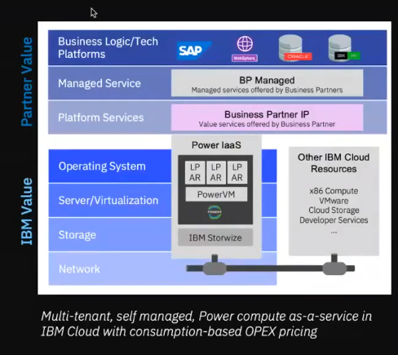

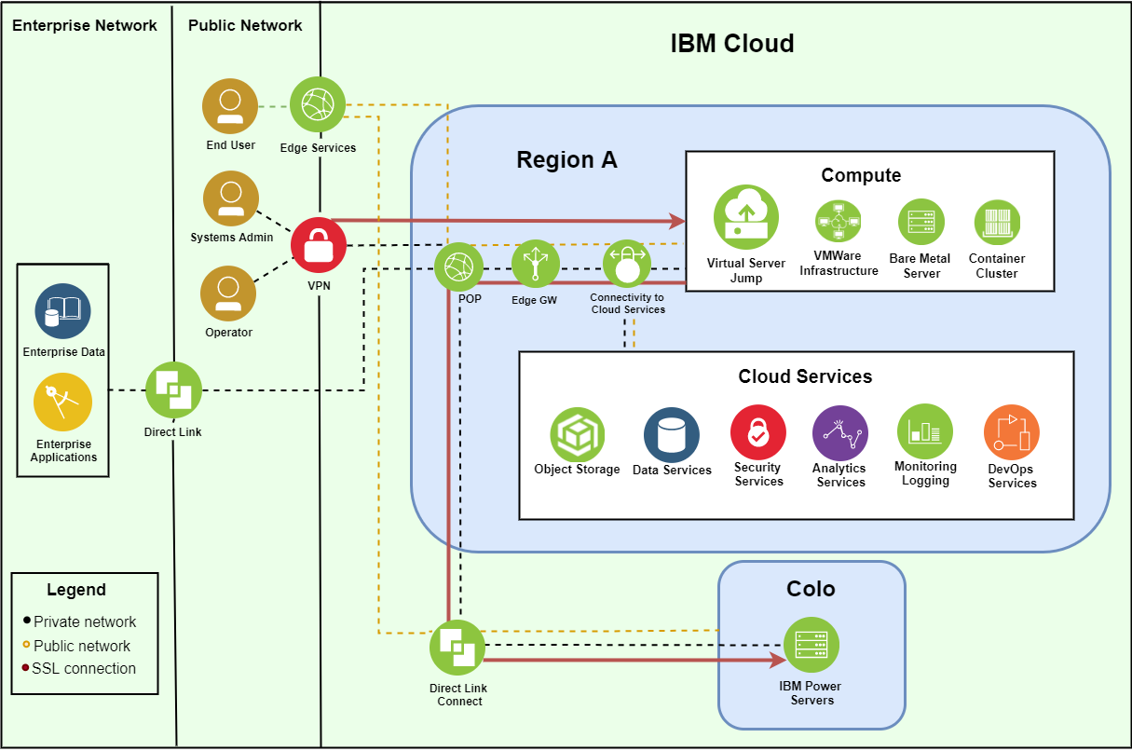

IBM CloudNative Resiliency Block Replicator (RBR)
IBM CloudNative AGENT BASED RBR is a host-based server-to-server replication product designed for a Disaster Recovery solution. In this block replication, the target Staging Appliance should be of the same OS family (AIX) as production LPAR. The block replicator agent is installed on Production LPAR and the target Staging Appliance.
It uses a large kernel buffer called the Big Asynchronous Buffer (BAB) to journal updates as they are written to the source volume.

Pstore
A Persistent Store (Pstore) is a volume on the Primary Server that stores state information and tracking data about the Replication Group as well bitmaps which track updates to the source volumes.

Mobility Groups
A Mobility Group is a collection of source disks or source volumes treated as a single unit by Block Replicator and the respective target disks which are defined as Replication pairs.
It allows time-ordered writing coherence between member replication pairs.

Note: IBM Guest OS-based RBR has been tested with up to 25 LPARs protection per DMC.

Architecture Overview
The solution describes “AIX Power VS application recovery with IBM resiliency orchestration using IBM CloudNative Agent based RBR”.
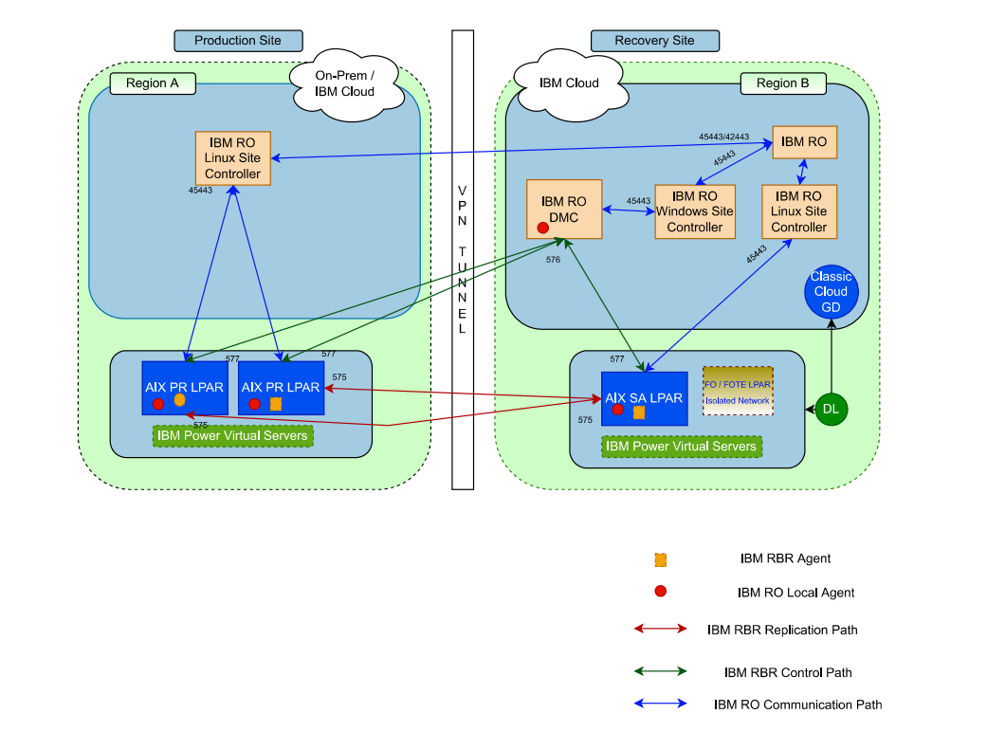
Figure 1 Architecture

The IBM Resiliency orchestration (IBM RO) is primarily deployed on the IBM Cloud DR region representing recovery site and the IBM RO component can also be set up as high availability across two regions. IBM RO deployed on Recovery site acts as active and the component on source site acts as Standby. IBM RO database replication occurs from active to standby using TCP Port 3306 which makes the database in sync state.

As in the diagram, each protected LPAR on the primary IBM cloud region (in IBM Power virtual servers’ environment) has an AGENT BASED RBR agent installed, and the Staging Appliance is set up on the target IBM cloud region (in the Colo of IBM Power virtual servers’ environment) for the production LPARs disks replication to target disks on the staging server. This solution is confined to only AIX operating system workloads and hence the staging server is an AIX server.

The number of Staging VMs depends on the number of Production LPAR workloads. IBM RBR agent is installed on Production workloads and Staging VMs.

IBM RBR component named DMC is deployed on Windows 2016/2019 LPAR running on IBM Cloud recovery region. It is used to create and manage Replication between Protected LPARs and Staging VMs. IBM Block Replicator synchronizes disk block-based data from LPAR disks on a Primary AIX LPAR (in primary IBM cloud region on IBM Power virtual servers’ environment) to DR AIX LPAR (in recovery IBM cloud region on IBM Power virtual servers’ environment) on a Secondary System (Staging VM), across any available TCP/IP network connection.
DMC communicates with LPARs via TCP port 576 and Production/Staging VMs to DMC via TCP port 575. The data path i.e., Block replicator agent communication between the protected LPARs and Staging VMs occurs at TCP port 575 in both directions.

IBM RO local agents are installed on Production, Staging VMs, and DMC. The site controller is deployed locally on the primary region and the recovery region to manage the production workloads, Staging VMs & DMC, and optimize the performance and scalability. IBM RO communicates with the Site controller via TCP Port 45443 for the respective components like DMC, Staging VMs, and Protected LPARs (Primary LPARs and DR LPARs).

In this solution, IBM RBR i.e., DMC and IBM Cloud endpoint is created as a Management service in IBM RO which is used to discover and protect IBM cloud (power virtual server instances) production LPARs.

Resiliency orchestration supports DR DRILLs with Failover test exercise with a set of standard workflows.
Also, it supports Replication Monitoring like RPO, Datalag, and generating alerts and reports.

In the case Failover test exercise, the test LPAR is created on the target IBM Cloud regions Power Virtual server components with pre-requisites defined by DR Admin, where production LPAR will be active as well as replication is not impacted. Clean-up of the Failover test exercise components is performed after the test activity completes.

Prerequisites
The prerequisites for this solution are as follows:
- IBM Cloud and Power Cloud API call to discover, protect and recover LPARs in specific region/s.
- Cloud-Native RBR (Block replicator) agent should be installed on IBM Power virtual server AIX Production LPAR instance.
- IBM Power virtual server AIX production LPAR should have one disk (size – 1G) added on production LPAR, required for Pstore (Cloud Native AGENT BASED RBR) purpose in either JFS or JFS2 file system.
- A Staging VM on the target side/cloud region on IBM Power virtual server with the same OS Family (AIX) is required with all the target replica disks presented/mapped respectively.
- The production LPAR and Staging VM should also have IBM RO local agent installed. In case an OS-level firewall is enabled, On AIX, it needs to have TCP ports 575, 577 and RO related ports (45443 default) opened.
- IBM Cloud Windows VM (Windows 2016/2019) should have Block Replicator DMC software installed. Also, it should have IBM RO local agent installed.
- It Needs .NET Framework 3.5 to be installed on windows for DMC package installation.
- In case an OS-level firewall is enabled; it needs to have TCP ports 577 open for In-Bound.
- In the case production AIX LPAR, Block Replicator needs at least 256 MB as physical memory for BAB purposes from the allocated LPAR Memory space.
- Staging VM needs 25% disk allocation of the total protected disk storage capacity (in addition to actual target/replica disks) for the Journal. It’s recommended to use SSD type/higher tier managed disk for Journal disk space allocation on Staging VM and mounted on Staging VM OS Disk.
- Journal disk should be formatted with native OS filesystem type and mounted as /journal
- The number of Staging VM size depends on the number of Protected LPAR disks and Staging VM Size.
- The Block replicator DMC and IBM Cloud/Power virtual service endpoint should be discovered in IBM RO as management services.
Port requirements

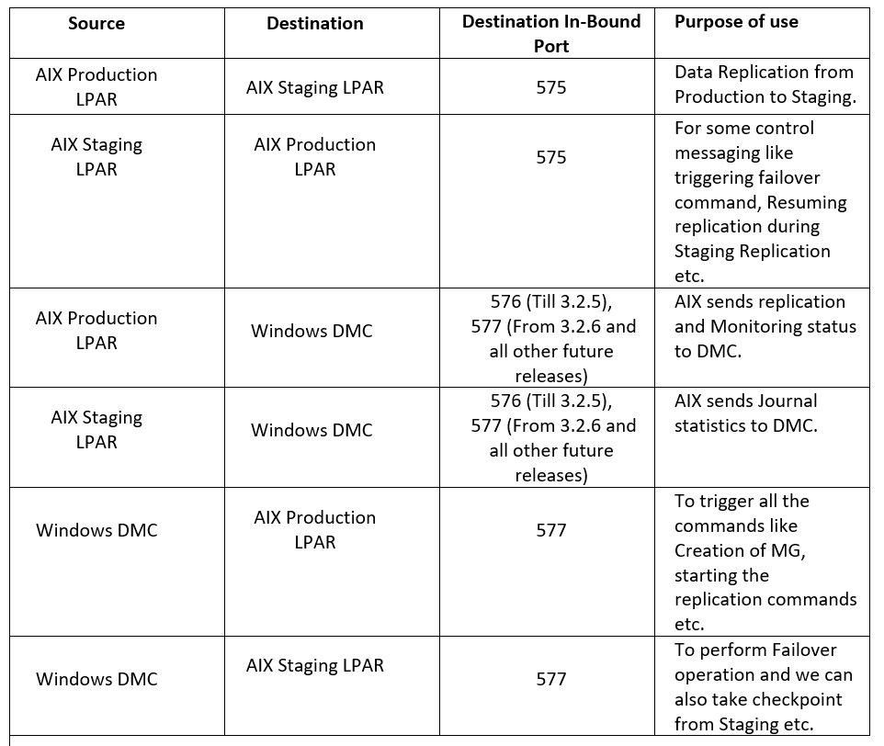

Security Requirements:
Category | Requirements | Detail | Comments
Production LPAR to target Staging Block Replicator LPAR | Port | Default – 575 | IBR Agent communication
IBM Cloud |  | Role with sufficient privileges to manage and deploy LPARs on PowerVS, manage storage and access to the relevant subscription  Below link for IBM Cloud Identity and access management  https://cloud.ibm.com/docs/account?topic=account-cloudaccess | Required for IBM RO to communicate with IBM Cloud Subscription for the managed resources discovery and protection for DR
DMC to Block Replicator Agent (Prod LPAR and SA VM) | Port | Default 576 (9476 in some scenarios) | Dtcagentset command is used to update this port at Block Replicator Agents
Block Replicator Agent to DMC | Port | Default 575 (576) | Dtcagentset command is used to update this port at Block Replicator Agents
DMC to SC | Port | 45443
IBM RO and Site controller to Power Virtual server instance AIX LPAR | Port | 443 | REST API
IBM Cloud API | Port | Default 443 | API Call (for supported API applicable)
IBM RO to SC | Port | 45443/42443

Supported Platforms and Versions
For the supported configurations, please refer to the latest IBM Resiliency Orchestration Interop List document.

Known Limitations
- Block replicator Guest OS Agent installation/uninstallation on Production workload LPAR, requires LPAR reboot.
- Pstore disk creation on Production LPAR is manual.
- Ip address assign: If we are using static in-network, then we have to manually log in to LPAR Console to configure the IP address.
- If we are using DHCP in-network, then the configuration of the IP address should be taken care of by the DHCP server.
- IBM RO local agent is required on PR LPARs, SA VM, and DMC (IBM Resiliency Orchestration Remote agent is not supported.)
- The solution doesn’t support Failover/Fallback/Switchover/Switchback features as of now.
- The maximum number of LPAR protection is 1000 per DMC.
- The solution supports only one DMC with one Resiliency Orchestration currently.
- Protected LPARs on Staging VM would be recovered on the target IBM Cloud Power virtual server service resource as same as Staging VM.
- The solution does not support auto-provisioning which means that the NFC workflow is not available and hence initial full sync needs to be performed manually and mobility group name needs to be entered during group discovery.
- AG auto-discovery is not supported and hence discovery needs to be performed per LPAR/RG.

Note: Any additional/default limitations at IBM Cloud/Power virtual services level may affect the Replication and Recovery.

Configuration

Sites
If Production and DR sites do not exist, you will have to create them. For information
on-site creation, refer to the Adding Sites topic in the IBM Resiliency Orchestration
Administrator’s guide.

Discovery

Management service
Discover the following services for primary and remote sites.

Note: You will need to discover AIX Management Service before discovering the Block Replicator V2 Management Service.

Adding AIX management Service
AIX management service must be added to complete the discovery of the AIX cluster.

To create an AIX Management Service, follow the below procedure:
- Log in to IBM Resiliency Orchestration.
- Click Discover -> Management Service tab. The existing management services, if any, are listed on the Management Service List page.
- Click Add Management Service link. The New Management Service page is displayed.
- Select a Resiliency Orchestration site from the Site drop-down list.
- Select IBMPCloud as the Management Service Type as shown in the screenshot below.

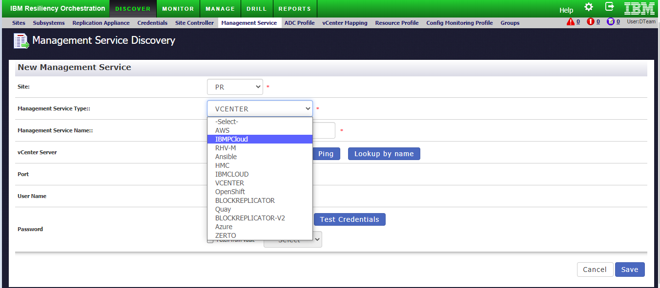
Note: The page refreshes with the relevant fields for creating an AIX Management Service and is as shown in the screenshot below.
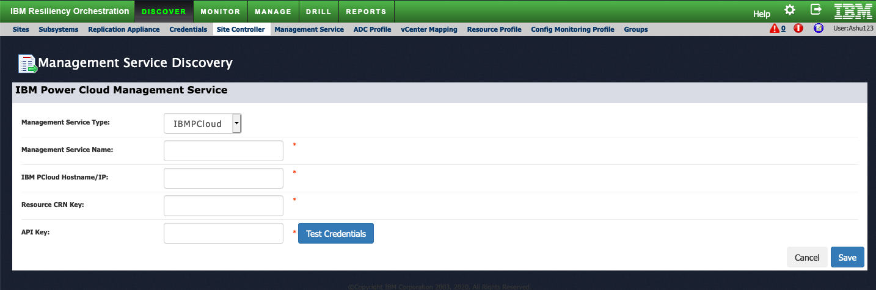
- Enter the management service name in the Management Service Name text box.
- Enter the IBM pCloud hostname or IP in the IBM pCloud Hostname/IP text box.
IBM PCloud Hostname/IP: us-<region>.power-iaas.cloud.ibm.com. The region depends on the region where the DR LPAR instance is created.
Example: If the LPAR is created in DALLAS then the region will be south. The region can be confirmed by checking the CRN key.
- Enter the resource CRN key in the Resource CRN Key text box.
Resource CRN Key: Go to the Cloud.ibm.com UI and click on the resource list. Expand the service and software dropdown and select the region where the DR LPAR instance is created. Copy the CRN value on the right side.

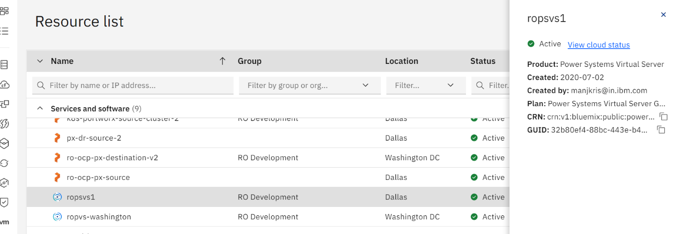
- Enter the API key in the API Key text box.
API Key: Go to manage dropdown and select Access (IAM)
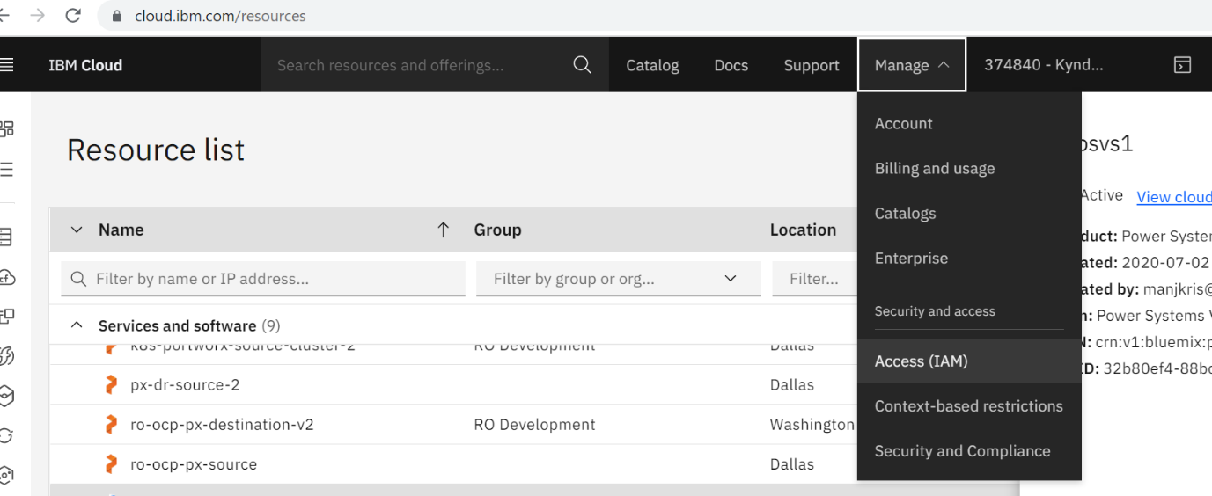
Select API keys and click on create an IBM Cloud API key
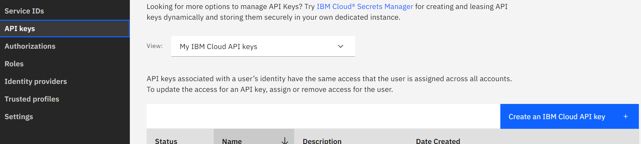
Download the API key created and copy the key generated.
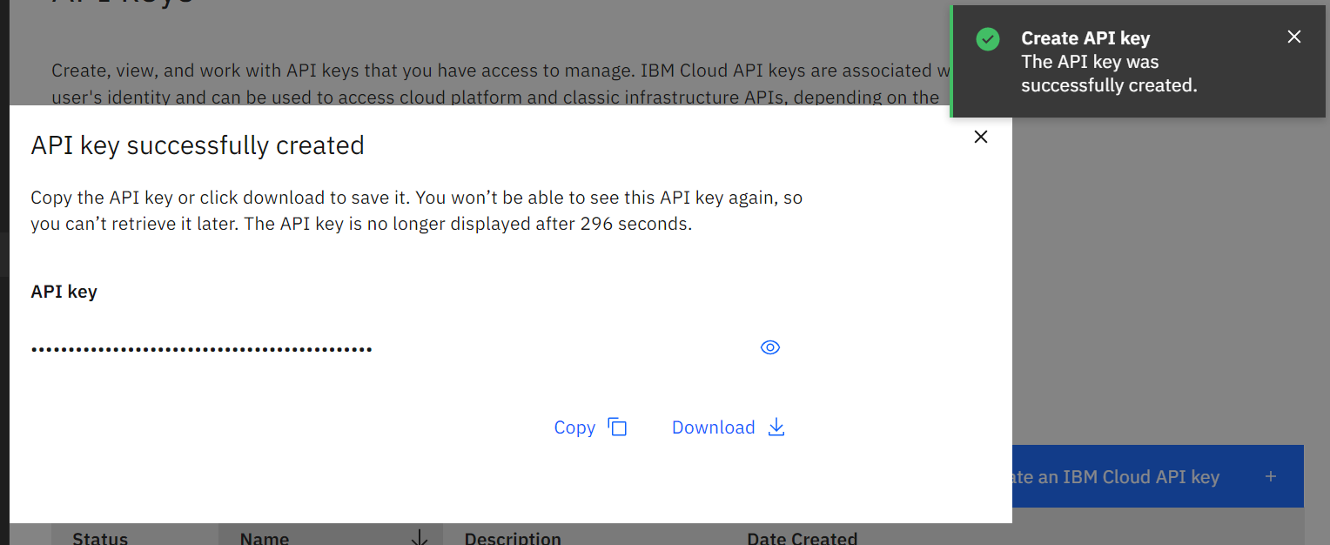

- Test the credentials and connectivity using the Test Credentials button.
- Click Save.
Note: The Management Service for the PR AIX Cluster is created. Repeat the procedure to create a Management Service for a Secondary/Disaster (DR) AIX cluster.

Viewing AIX Credentials
- Navigate to the management service page
- Click on the Management Service name (user-defined.) to view the credentials.

Editing AIX Credentials
- Navigate to the management service page
- Click on the edit icon corresponding to the management service name.
Note: You can edit the password only.
- Update the password field, and then click the Save button.

Adding BlockReplicator-V2 management service
BlockReplicator-V2 management service must be added for connecting it with the IBM Resiliency Orchestration.
To create an AIX Management Service, perform the following steps:
- Log in to IBM Resiliency Orchestration.
- Click Discover -> Management Service tab. The existing management services, if any, are listed on the Management Service List page.
- Click Add Management Service link. The New Management Service page is displayed.
- Select a Resiliency Orchestration Site from the Site drop-down list.
- Select “BLOCKREPLICATOR-V2” as the Management Service Type as shown in the screenshot below.
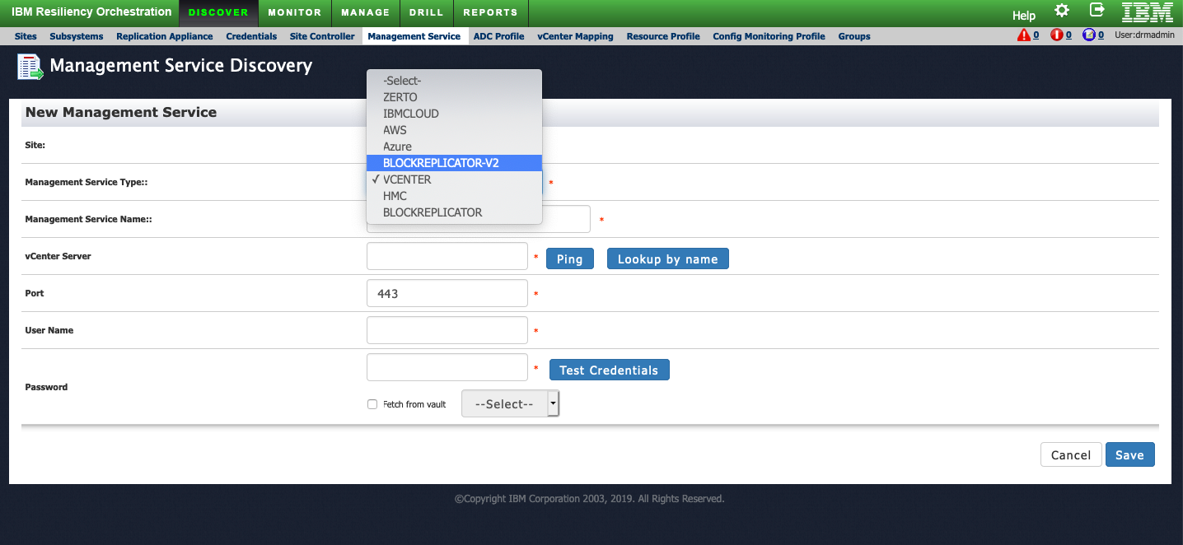
The page refreshes with the relevant fields for creating an AIX Management Service and is as shown in the screenshot below.
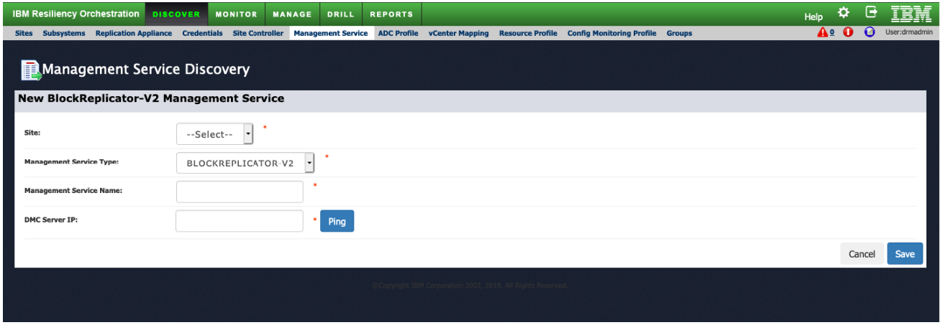
- Select the Site from the dropdown list.
- Enter Management Service name and DMC Server IP.
- Test the connectivity using the Ping button.
- Click Save.

For the remote site, perform the following steps:

- Discover Region, Network (VNET/Subnet/SecurityGroup), Security Group.
- Select AIX MGMTSERVICE > REGION (RAL2, RAL-3).
- Select Subscription from the list.
- Discover Resource Group in given Region.
- VNET_NAME > SUBNET (RAL-6).
- SECURITY GROUP (RAL-7).

Creating Recovery Group
The LPAR protection using AIX with Agent-based RBR group will be discovered using the wizard from the group discovery page. This is a low touch wizard which requires minimal user intervention to create the group.

Note: DMC management service and AIX management service should be discovered.

To create the group, perform the following steps:

- Select Discover > Groups. The Group listing page displays.
- Select Power VS on IBM Cloud with RBR from the panel on the right side of the page. Create Recovery Group page is displayed.
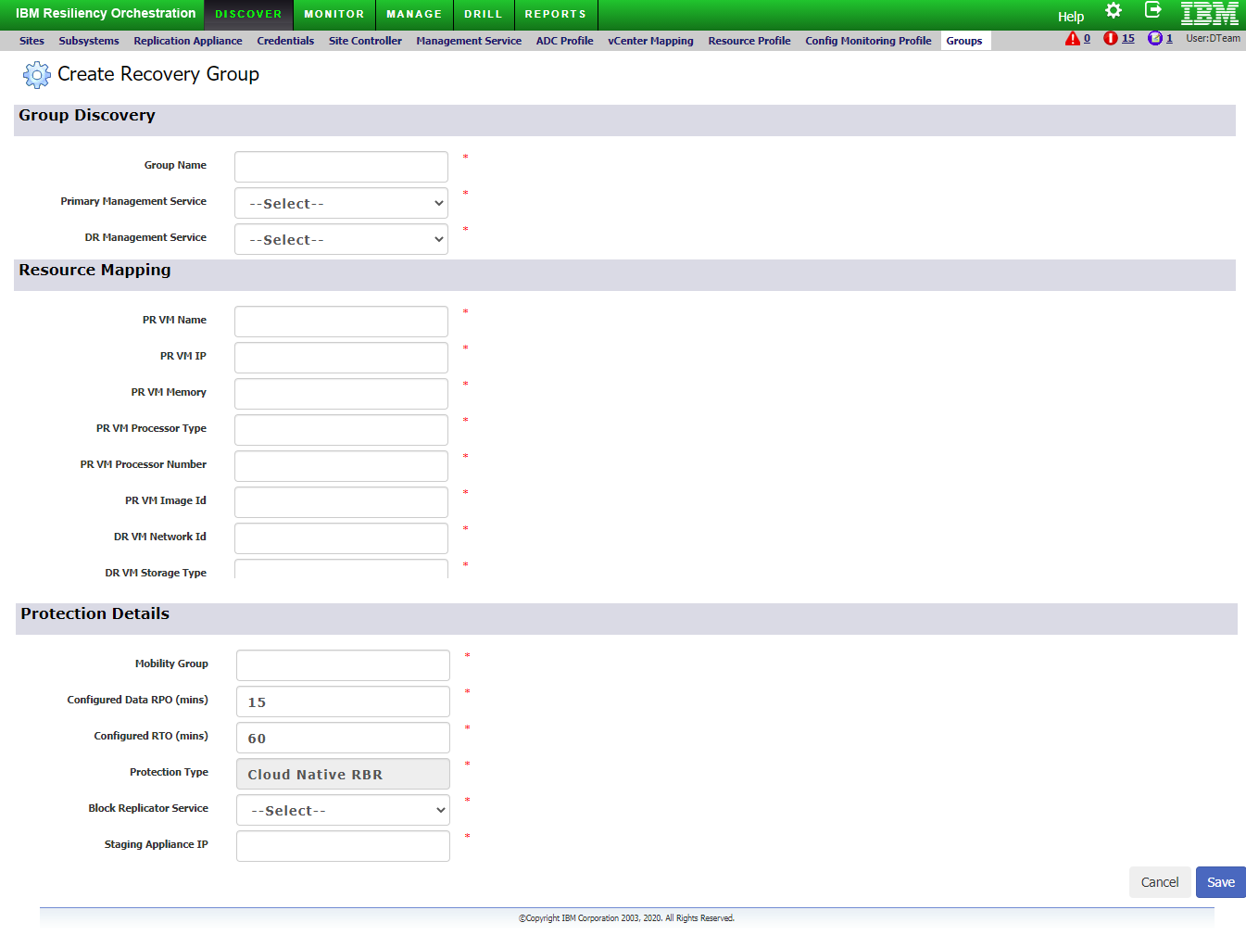
- Under the Group Discovery section,
  - Enter the group name in the Group Name text box.
  - Select the primary and remote AIX management services from the respective Primary Management Service and DR Management Service dropdown lists.
- Under the Resource Mapping section,
  - Enter the primary site LPAR in the PR LPAR Name textbox.
  - Enter the primary site LPAR IP in the PR LPAR IP textbox.
  - Enter the primary site memory in the PR Memory textbox.
  - Enter the primary site processor number in the PR Processor Number textbox.
  - Enter the primary site image ID in the PR Image Id textbox.
  - Enter the Remote site network ID in the DR Network Id textbox.
  - Enter the Remote site storage type in the DR Storage Type textbox.
- Under the Protection Details section,
  - Enter the mobility group number in the Mobility Group text box.
  - Enter the RPO time in the minute format in the Configured Data RPO (mins).
Note: The default RPO is set to 15 minutes.
  - Enter the RTO time in the Configured RTO (min).
Note: The default RTO is set to 60 minutes.
  - Select the block replicator service from the Block Replicator Service dropdown list
  - Enter the staging appliance IP in the Staging Appliance IP textbox.
- Click the Save button to create the recovery group.

Group creation:

- Log in to the RO GUI. On the home page click on Discover, it will open the Groups page. Select Create Group on the right-hand side.
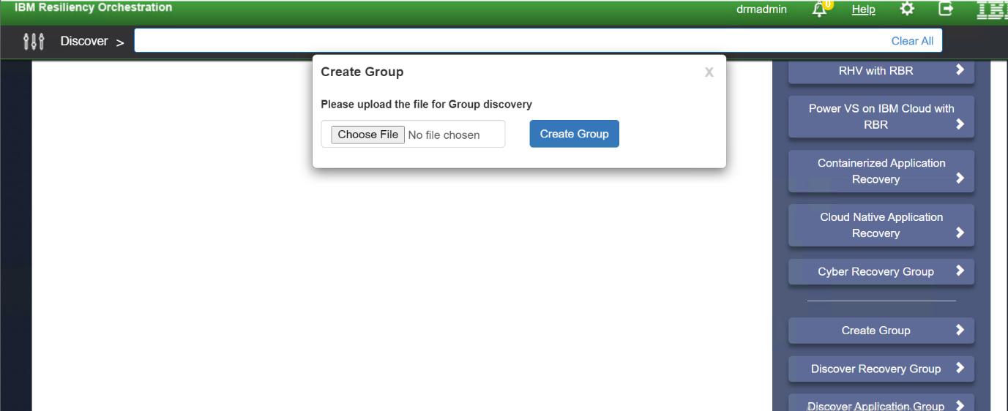
Click on Choose File and search for the JSON file on the local setup and click on Create Group to upload it to RO.

JSON File to be uploaded
Details for additional properties:
"additionalProperties":[
{
"key":"PR_DIS_VM_NAME",
"value":"<DR FOTe VM NAME>"
},
{
"key":"PR_DIS_VM_IP",
"value":"<DR FOTe VM IP>"
},
{
"key":"PR_DIS_MEMORY",
"value":"<DR FOTe VM Memory size >"
},
{
"key":"PR_DIS_PROC_TYPE",
"value":"<capped/uncapped>"
},
{
"key":"PR_DIS_PROC_NUMBER",
"value":"<DR FOTe VM Processor >"
},
{
"key":"DR_DIS_IMAGE_ID",
"value":"<Image ID of AIX>"
},
{
"key":"DR_DIS_NETWORK_ID",
"value":"<Zone Network ID>"
},
{
"key":"DR_DIS_STORAGE_TYPE",
"value":"<DR VM Storage type>" <should be similar to the storage type of the DR SA VM>
},
{
"key":"DR_DIS_STORAGE_POOL",
"value":"<DR VM Storage Pool>" < should be similar to the storage type of the DR SA VM >
},
{
"key":"SA_Dis_VM_IP",
"value":"<SA IP>"
},
{
"key":"Mobility_Group",
"value":"<MG Number>"
},
{
"key":"domainName",
"value":"(not specified)"
},
{
"key":"journalPath",
"value":"/Journal"
},
{
"key":"pstoreDir",
"value":"/dev/pstore"
},
{
"key":"DRStagingApplianceIP",
"value":"<DR IP>"
},
{
"key":"MANAGEMENT_SERVICE",
"value":"DMC"
},
{
"key": "ProtectionType",
"value": "CloudNativeRBR"
}

Subsystem Discovery
Discovery is the operation by which we identify the various “objects” participating in a pre-existing implementation of the objects that will have to be created as part of the solution.

Component
Components will be auto discovered when the LPAR protection using AIX with AGENT BASED RBR group is created. For each LPAR, components of LPAR’s OS type will be auto discovered for Primary and Remote sites.

Dataset
Dataset is not applicable for this solution.

Protection Schema
Primary Protection scheme
- Cloud-Native Block Replicator agent status (Protected LPAR RBR Agent status)
DR Protection scheme
- Cloud-Native Block Replicator agent status (Staging LPAR RBR Agent status)
Note: Manual RG/Appstack discovery or bulk upload option from IBM RO should be available for AIX LPAR Protection.

Group Monitoring

RPO/RTO Monitoring
This section corresponds to the Monitor RPO/RTO screen of IBM Resiliency Orchestration for this solution.
- Recovery Point Objective – App RPO (This solution does not support App RPO)
- Recovery Point Objective – Data RPO
Computing data replicated to the target and not applied in the target database is Data RPO.

Recovery Time Objective
RTO is the estimated time required for the secondary/DR site to be ready and available in case the primary goes down. For this solution, it is calculated based on the use cases used as part of recovering the LPARs.

Replication Monitoring
This section corresponds to the “Monitor → Group → Pending Data” tab of IBM Resiliency Orchestration. The table shows the monitored information and how it is obtained. When there is more than one protection manager object involved in the protection then some of these parameters will have to be calculated at each manager object in addition to primary and secondary protection objects.

RG Datalag
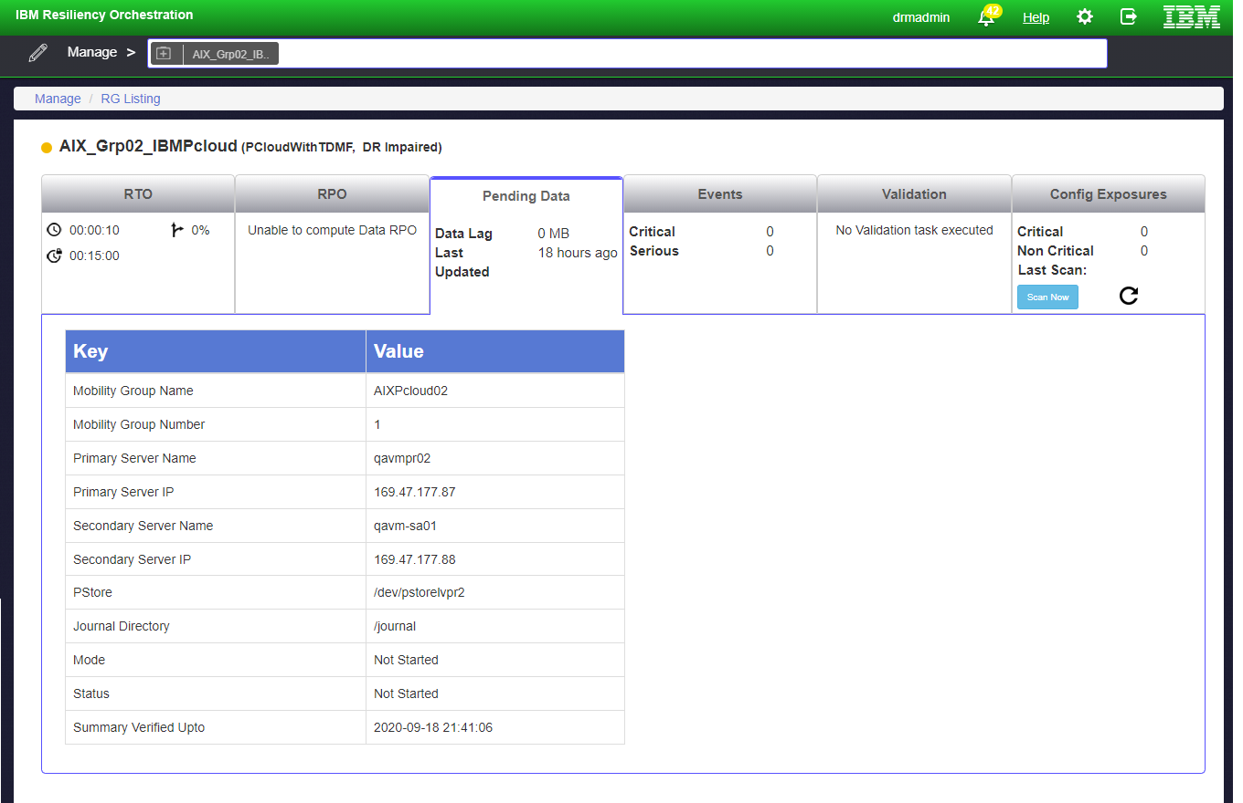

Datalag
AIX with AGENT BASED RBR provides Data LAG for the protected LPAR based on Replication Mobility Group.

Drills
This section covers the test exercises of IBM Resiliency Orchestration.

Failover Test Exercise
Perform the following steps.

Prerequisite:
After group creation goes to the drills page. Preloaded workflow is available for execution. Perform the following steps.
- IBM Cloud Management service and credentials are available.
- Ensure the following resource details are available.
  - ResourceGroupName.
  - Primary LPAR details.
  - Staging LPAR.
  - Replicated Disk_ID.
  - DMC Management Service.
  - Replication OS level Disk detail.
  - IBM Power Cloud Network details (eg. subnet/network ID).
  - Processor type and numbers.
  - Memory details.
- The network. connectivity should be available between primary and remote sites.
- A pre-created network and one AIX image should be available on the remote site.
- The network connectivity should be available between on-premises and the Pcloud region.
- If RO and dmc box are on IBM cloud, then there should be n/w connectivity between IBM cloud and IBM Power cloud.

Note: Add Key Values manually as described in the following table.
NAME | Description | Sample Value
DR_DATA_VOLUME_ID | Name of the Data disk n the Staging Appliance. | ["datadisk1", datadisk 2"]
DR_OS_VOLUME_ID | Name of the OS replicated disk on the Staging Appliance. | [osdiskname]

Notes:
• The sample values within “[“and “]” represent variable values (comma separated).
• Adding key is a one-time activity. We can execute FOTE multiple times.

Steps:
You can perform FOTE by navigating from the home page to Drill > Summary tab.
Following RALs are executed once the FOTE is triggered:
- Execute the RAL CreateVmWithAIXImage
- Execute the RAL CheckReplicatusStatus
- Execute the RAL EnableIBRCheckpoint
- Execute the RAL CloneReplicatedDisksOs
- Execute the RAL CloneReplicatedDisksData
- Execute the RAL DisableIBRCheckpoint
- Execute the RAL GetAixImageRootVolumeInformation
- Execute the RAL MakeClonedOsdiskBootable
- Execute the RAL StopVmAIX
- Execute the RAL CreateHelperDIskOneGb
- Execute the RAL MakeHelperDiskBootable
- Execute the RAL AttachHeperDiskAixVm
- Execute the RAL AttachClonedDatadisk
- Execute the RAL SetBootHelperDisk
- Execute the RAL DetachRootDiskAixImageFromVm
- Execute the RAL DeleteRootDiskAIXImage
- Execute the RAL AttachClonedOsdisk
- Execute the RAL SetBootClonedOsDisk
- Execute the RAL DetachHelperDisk
- Execute the RAL DeleteHelperDisk
- Execute the RAL StartVmAIX
- Execute the RAL GetAIXVmDetails
- Execute the RAL DeleteAixVm
- Execute the RAL DeleteClonedDataDisk
- Execute the RAL DeleteRootDiskAixImage

Notes:

- FOTE LPAR has to be bought up in an isolated/bubble network where the communication to DMC and Prod LPAR is restricted. This is to avoid conflicts with the production environment and also the DMC mobility group.

- If the AIX instance takes longer than the set timeout value of 5 minutes in the RAL to allow the Disk addition and deletion management tasks, that task needs to retry when the AIX instance disk management is available.

FOTE Workflow on-prem to the cloud:
- Create the mobility group with the boot and data disks and start the replication.
- Add the correct values in the JSON file of the mobility and create the RG.
- Monitor the status of the group from the RO Monitor page after selecting the RG added above.
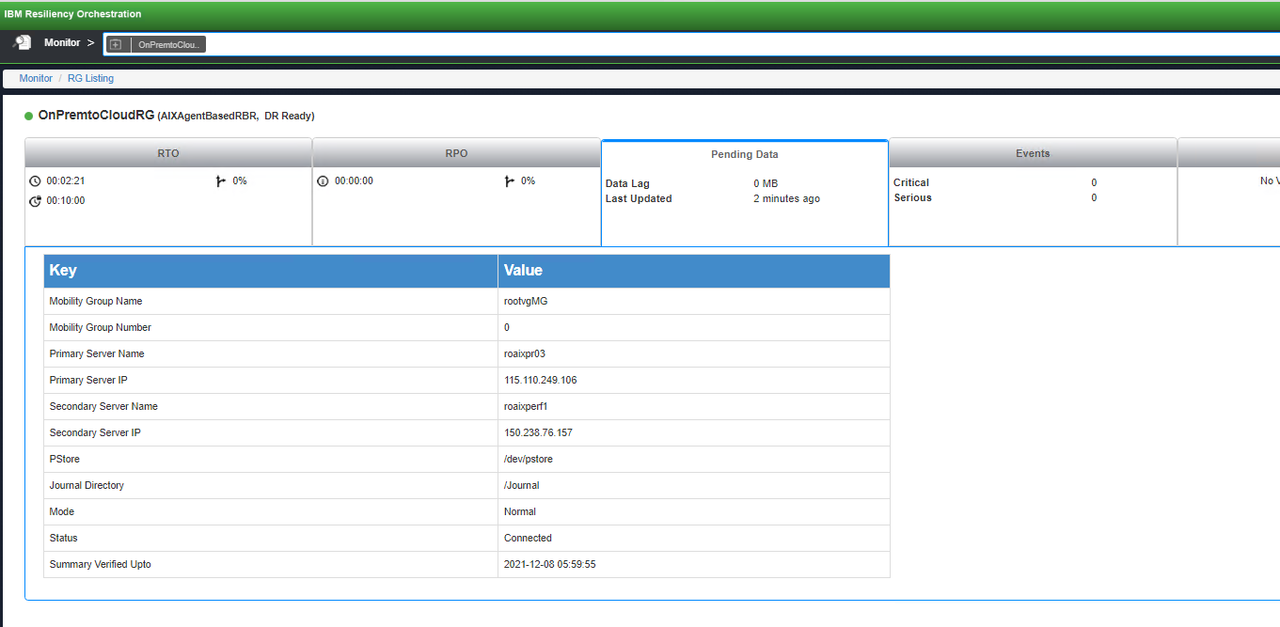

- After the groups are in the normal state, go to the Drill page and go to the Summary tab and select Recovery Groups in the dropdown menu and select the cluster configured RG.
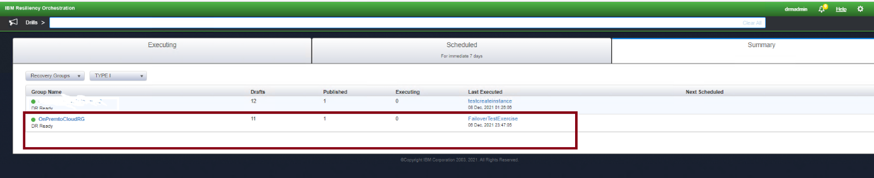

- On the Drill page for the selected RG, edit the FailoverTestExercise workflow.
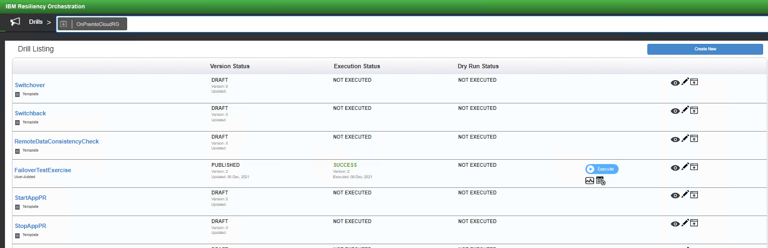

- Import the failover workflow for on-prem to cloud from $EAMSROOT/opt/panaces/rpd/solutionPlugins/AIXAgentBasedRBR/ibmclud_cluster_workflow.xml

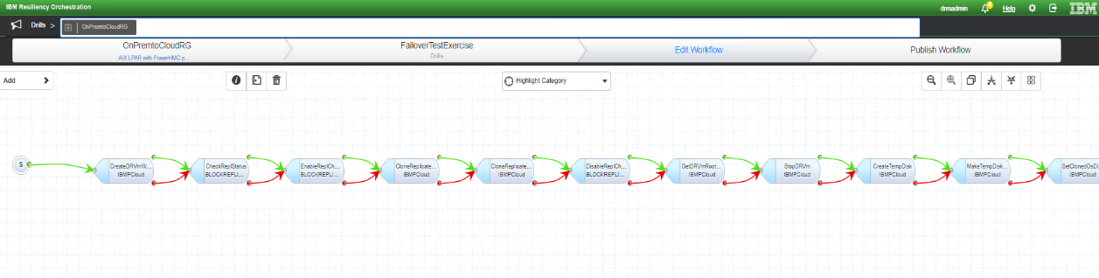

- Go to the next page and enter the key-value pair for the SA disks with the correct replicated data disk and the root disk as below:
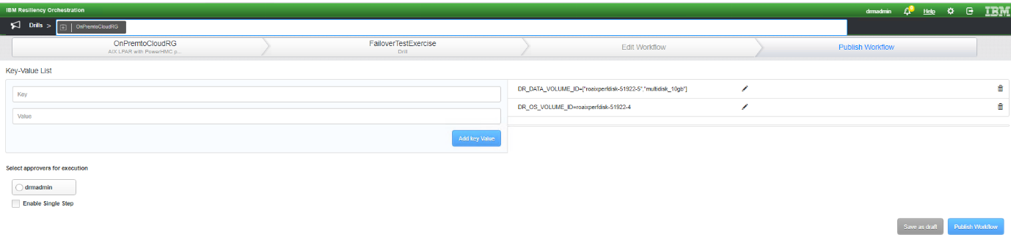

Now publish the workflow and start the FOTE execution.
FOTE Workflow Steps:
- CreateDRVmWithSelectedImage
- CheckReplStatus
- EnableReplCheckpoint
- CloneReplicatedOSDisk
- CloneReplicatedDataDisks
- DisableReplCheckpoint
- GetDRVmRootVolInfo
- StopDRVm
- CreateTempDisk
- MakeTempDiskBootable
- SetClonedOsDiskBootable
- AttachTempDiskToDRVm
- AttachClonedDataDisksToDRVm
- SetTempDiskAsDRVmBootDisk
- DetachDRVmRootDisk
- AttachClonedOSdisk
- DeleteDetachedRootDisk
- SetBootClonedOsDisk
- DetachTempDisk
- DeleteTempDisk
- StartDRVm
- GetDRVmDetails
- DeleteDRVm
- DeleteClonedDataDisk

FOTE Workflow Cluster OnPrem to Cloud:
- Create the mobility group with the shared cluster disk and start replication. Create another group with the boot disk of one of the cluster nodes and start the replication on that as well.
- Add the correct values in the JSON file of the mobility group that has the shared disk and create the RG. Optionally add the RG for the MG with the root disk replication pair.
- Monitor the status of the group from the RO Monitor page after selecting the RG added above.
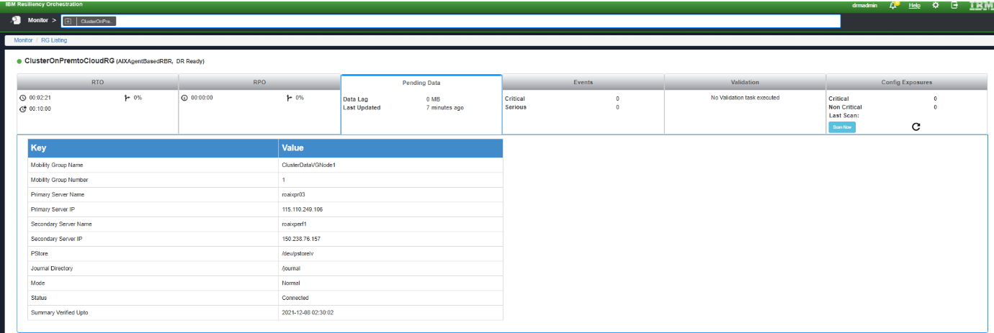

- After the groups are in the normal state, go to the Drill page and go to the Summary tab and select Recovery Groups in the dropdown menu and select the cluster configured RG.

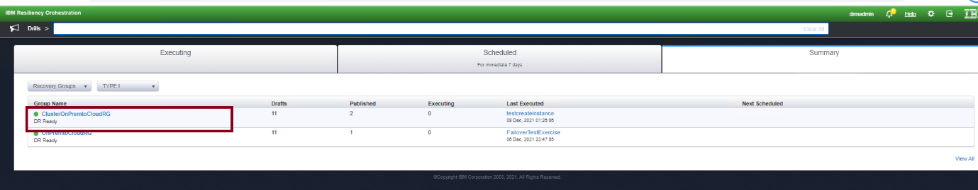

- On the Drill page for the selected RG, edit the FailoverTestExercise workflow.

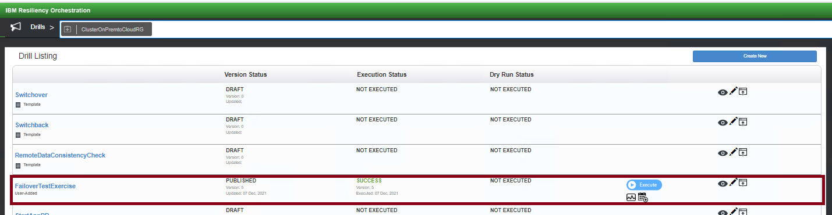

- Import the failover workflow for cluster configuration from $EAMSROOT/opt/panaces/rpd/solutionPlugins/AIXAgentBasedRBR/AIX_Onprem_to_IBMCloud_FOTE.xml

- For cluster Fote, we need to add two additional RALs have been added where we need to enter the details of the root MG. Click on the second EnableReplCheckpoint RAl and go to ActionProperties and add the correct values related to the root MG.
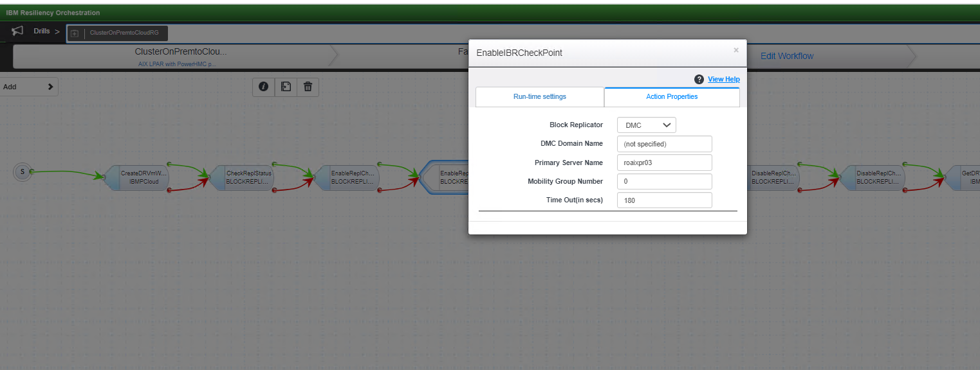

- Do the same for the second DisableReplCheckpoint RAL and save the workflow.
- Go to the next page and enter the key-value pair for the SA disks with the correct replicated data disk (cluster disk on PR) and the root disk.
Note- If the root MG has other data disks then we can add them also here with the format as below:
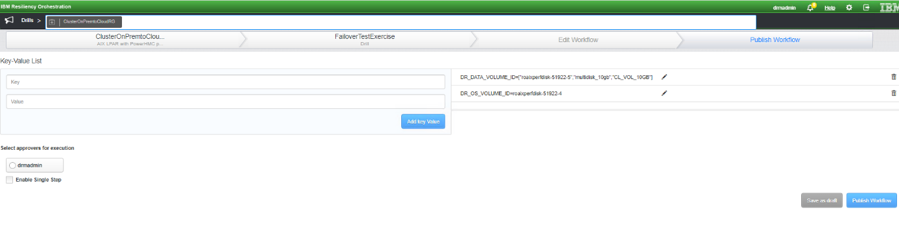

Now publish the workflow and start the FOTE execution.
FOTE Steps:
1.CreateDRVmWithSelectedImage
2.CheckReplStatus
3.EnableReplCheckpoint
4.EnableReplCheckpoint
5.CloneReplicatedOSDisk
6.CloneReplicatedDataDisks
7.DisableReplCheckpoint
8.DisableReplCheckpoint
9.GetDRVmRootVolInfo
10.StopDRVm
11.CreateTempDisk
12.MakeTempDiskBootable
13.SetClonedOsDiskBootable
14.AttachTempDiskToDRVm
15.AttachClonedDataDisksToDRVm
16.SetTempDiskAsDRVmBootDisk
17.DetachDRVmRootDisk
18.AttachClonedOSdisk
19.DeleteDetachedRootDisk
20.SetBootClonedOsDisk
21.DetachTempDisk
22.DeleteTempDisk
23.StartDRVm
24.GetDRVmDetails
25.DeleteDRVm
26.DeleteClonedDataDisk

Reports
You can generate reports on various continuity management and monitoring metrics that include RPO, RTO, and continuity operations for Groups under IBM Resiliency Orchestration management. All applicable reports are available for this solution.
To view all reporting-related documentation, please refer to the Reports section in IBM Resiliency Orchestration Admin Guide.

